Chapter 6 - Strings, I/O, Formatting, and Parsing

Strings

String s = new String(); // Note strings are objects and ‘S’ is capital

Once you have assigned a String a value, that value can never change— it's immutable.

While the String object is immutable, its reference variable is not.

Devilish string question

String s1 = "spring ";
String s2 = s1 + "summer ";
s1.concat("fall ");
s2.concat(s1);
s1 += "winter ";
System.out.println(s1 + " " + s2);

What is the output? For extra credit, how many String objects and how many reference variables were created prior to the println statement?

Answer: The result of this code fragment is "spring winter spring summer". There are two reference variables, s1 and s2. There were a total of eight String objects created as follows: "spring", "summer " (lost), "spring summer", "fall" (lost), "spring fall" (lost), "spring summer spring" (lost), "winter" (lost), "spring winter" (at this point "spring" is lost). Only two of the eight String objects are not lost in this process.

String s = "abcdef"; // create a new String object, with value "abcdef", refer s to it
String s2 = s; // create a 2nd reference variable

// referring to the same String
// create a new String object, with value "abcdef more stuff",
// refer s to it. (Change s's reference from the old String
// to the new String.) ( Remember s2 is still referring to
// the original "abcdef" String.)

s = s.concat(" more stuff");

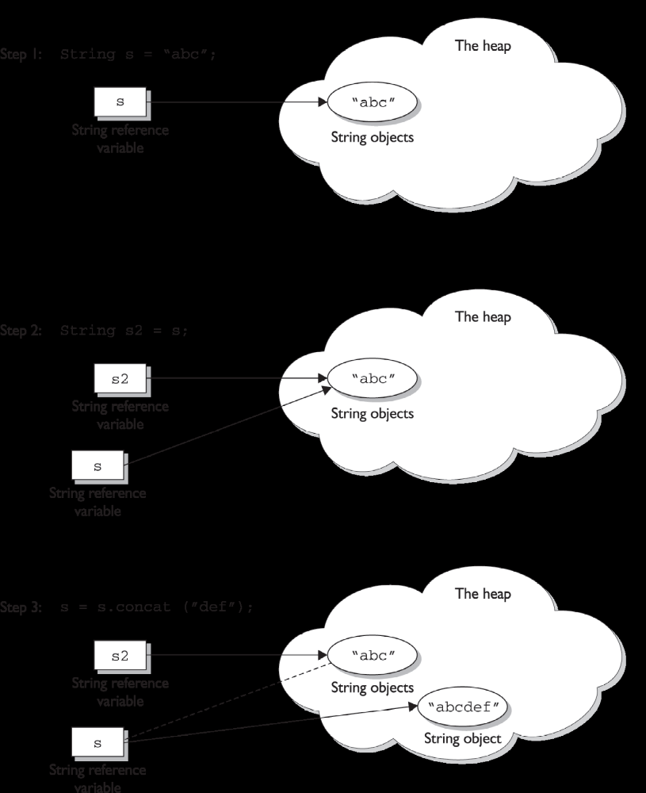

Let's look at another example:

String x = "Java";
x.concat(" Rules!");
System.out.println("x = " + x); // the output is "x = Java"

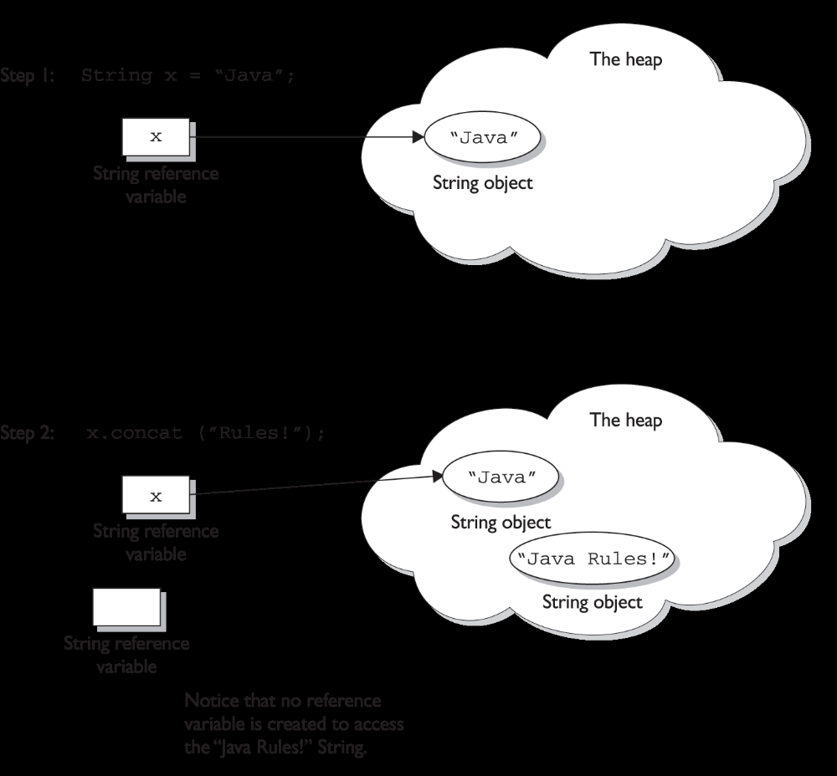

But we can put a small spin on the previous example:

String x = "Java";
x = x.concat(" Rules!"); // Now we're assigning the new String to x
System.out.println("x = " + x); // the output will be: // x = Java Rules!

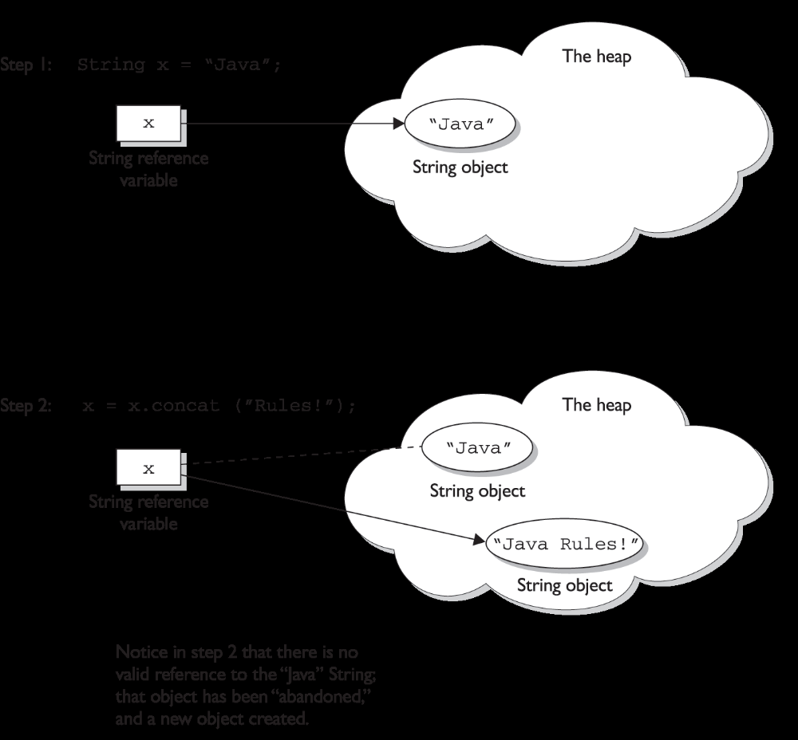

To make Java more memory efficient, the JVM sets aside a special area of memory called the "String constant pool." When the compiler encounters a String literal, it checks the pool to see if an identical String already exists. If a match is found, the reference to the new literal is directed to the existing String, and no new String literal object is created.

The String class is marked final. Nobody can override the behaviors of any of the String methods, so you can rest assured that the String objects you are counting on to be immutable will, in fact, be immutable.

String s = "abc"; // creates one String object and one reference variable

In this simple case, "abc" will go in the pool and s will refer to it.

String s = new String("abc"); // creates two objects,and one reference variable

In this case, because we used the new keyword, Java will create a new String object in normal (non-pool) memory, and s will refer to it. In addition, the literal "abc" will be placed in the pool.

Important Methods in the String Class

public char charAt(int index)

String x = "airplane";
System.out.println( x.charAt(2) ); // output is 'r'

public String concat(String s)

String x = "taxi";
System.out.println( x.concat(" cab") ); // output is "taxi cab"

public boolean equalsIgnoreCase(String s)

String x = "Exit";
System.out.println( x.equalsIgnoreCase("EXIT")); // is "true"
System.out.println( x.equalsIgnoreCase("tixe")); // is "false"

public int length()

String x = "01234567";
System.out.println( x.length() ); // returns "8"

public String replace(char old, char new)

String x = "oxoxoxox";
System.out.println( x.replace('x', 'X') ); // output is "oXoXoXoX"

public String substring(int begin)
public String substring(int begin, int end)

String x = "0123456789"; // as if by magic, the value of each char is the same as its index!
System.out.println( x.substring(5) ); // output is "56789"
System.out.println( x.substring(5, 8)); // output is "567"

public String toLowerCase()

String x = "A New Moon";
System.out.println( x.toLowerCase() ); // output is "a new moon"

public String toString()

String x = "big surprise";
System.out.println( x.toString() ); // output is "big surprise"

public String toUpperCase()

String x = "A New Moon";
System.out.println( x.toUpperCase() ); // output is "A NEW MOON"

public String trim()

String x = " hi ";
System.out.println( x + "x" ); // result is " hi x"
System.out.println( x.trim() + "x"); // result is "hix"

The StringBuffer and StringBuilder Classes

A common use for StringBuffers and StringBuilders is file I/O when large, ever-changing streams of input are being handled by the program. In these cases, large blocks of characters are handled as units, and StringBuffer objects are the ideal way to handle a block of data, pass it on, and then reuse the same memory to handle the next block of data.

The java.lang.StringBuffer and java.lang.StringBuilder classes should be used when you have to make a lot of modifications to strings of characters. As we discussed in the previous section, String objects are immutable, so if you choose to do a lot of manipulations with String objects, you will end up with a lot of abandoned String objects in the String pool. On the other hand, objects of type StringBuffer and StringBuilder can be modified over and over again without leaving behind a great effluence of discarded String objects.

The StringBuilder class was added in Java 5. It has exactly the same API as the StringBuffer class, except StringBuilder is NOT thread safe. In other words, its methods are not synchronized. Sun recommends that you use StringBuilder instead of StringBuffer whenever possible because StringBuilder will run faster.

Using StringBuilder and StringBuffer

StringBuffer sb = new StringBuffer("abc");
sb.append("def");
System.out.println("sb = " + sb); // output is "sb = abcdef"

All of the StringBuffer methods we will discuss operate on the value of the StringBuffer object invoking the method

These method calls can be chained to each other—for example,

StringBuilder sb = new StringBuilder("abc");
sb.append("def").reverse().insert(3, "---");
System.out.println( sb ); // output is "fed---cba"

Notice that in each of the previous two examples, there was a single call to new, concordantly in each example we weren't creating any extra objects.

Methods in the StringBuffer and StringBuilder Classes

public synchronized StringBuffer append(String s)

This method will update the value of the object that invoked the method, whether or not the return is assigned to a variable. This method will take many different arguments, including boolean, char, double, float, int, long, and others, but the most likely use on the exam will be a String argument—for example,

StringBuffer sb = new StringBuffer("set ");
sb.append("point");
System.out.println(sb); // output is "set point"

StringBuffer sb2 = new StringBuffer("pi = ");
sb2.append(3.14159f);
System.out.println(sb2); // output is "pi = 3.14159"

public StringBuilder delete(int start, int end)

This method returns a StringBuilder object and updates the value of the StringBuilder object that invoked the method call.

StringBuilder sb = new StringBuilder("0123456789");
System.out.println(sb.delete(4,6)); // output is "01236789"

public StringBuilder insert(int offset, String s)

StringBuilder sb = new StringBuilder("01234567");
sb.insert(4, "---");
System.out.println( sb ); // output is "0123---4567"

public synchronized StringBuffer reverse()

StringBuffer s = new StringBuffer("A man a plan a canal Panama");
sb.reverse();
System.out.println(sb); // output: "amanaP lanac a nalp a nam A"

public String toString()

StringBuffer sb = new StringBuffer("test string");
System.out.println( sb.toString() ); // output is "test string"

Unlike Strings, StringBuffer objects and StringBuilder objects can be changed.

Chained methods

1. Determine what the leftmost method call will return (let’s call it x).

2. Use x as the object invoking the second (from the left) method. If there are only two chained methods, the result of the second method call is the expression's result.

3. If there is a third method, the result of the second method call is used to invoke the third method, whose result is the expression’s result—for example,

String x = "abc";
String y = x.concat("def").toUpperCase().replace('C','x'); //chained methods
System.out.println("y = " + y); // result is "y = ABxDEF"

Let’s look at what happened. The literal def was concatenated to abc,creating a temporary, intermediate String (soon to be lost), with the value abcdef. The
toUpperCase() method created a new (soon to be lost) temporary String with the value ABCDEF. The replace() method created a final String with the value ABxDEF, and referred y to it.

File Navigation and I/O

Create file example

import java.io.*; // The Java 5 exam focuses on classes from java.io
class Writer1 {
public static void main(String [] args) {
File file = new File("fileWrite1.txt"); // There's no file yet!
}
}

When you make a new instance of the class File, you're not yet making an actual file, you're just creating a filename.

Let's see what we can do with the File object we just made:

import java.io.*;
class Writer1 {
public static void main(String [] args) {
try { // warning: exceptions possible
boolean newFile = false;
File file = new File ("fileWrite1.txt"); // it's only an object
System.out.println(file.exists()); // look for a real file
newFile = file.createNewFile(); // maybe create a file!
System.out.println(newFile); // already there?
System.out.println(file.exists()); // look again
} catch(IOException e) { }
}
}

This produces the output

false
true
true

And also produces an empty file in your current directory. If you run the code a second time you get the output

true
false
true

File class methods used in above code

- boolean exists() This method returns true if it can find the actual file.

- boolean createNewFile() This method creates a new file if it doesn't already exist.

Remember, the exam creators are trying to jam as much code as they can into a small space, so in the previous example, instead of these three lines code,

boolean newFile = false;
...
newFile = file.createNewFile();
System.out.println(newFile);

You might see something like the following single line of code, which is a bit harder to read, but accomplishes the same thing:

System.out.println(file.createNewFile());

Using FileWriter and FileReader

import java.io.*;

class Writer2 {
public static void main(String [] args) {
char[] in = new char[50]; // to store input
int size = 0;
try {
File file = new File("fileWrite2.txt"); // just an object
FileWriter fw = new FileWriter(file); // create an actual file & a FileWriter obj
fw.write("howdy\nfolks\n"); // write characters to the file
fw.flush(); // flush before closing
fw.close(); // close file when done

FileReader fr =
new FileReader(file); // create a FileReader object
size = fr.read(in); // read the whole file!
System.out.print(size + " "); // how many bytes read
for(char c : in) // print the array
System.out.print(c);
fr.close(); // again, always close
} catch(IOException e) { }
}
}
which produces the output:

12 howdy
folks

Invoking the flush() method, guarantees that the last of the data you thought you had already written actually gets out to the file.

Table 6.2 on page 26 – java.io mini API

1. We know that ultimately we want to hook to a File object. So whatever other class or classes we use, one of them must have a constructor that takes an object of type File.

2. Find a method that sounds like the most powerful, easiest way to accomplish the task. When we look at Table 6-1 we can see that BufferedWriter has a newLine() method. That sounds a little better than having to manually embed a separator after each line, but if we look further we see that PrintWriter has a method called println(). That sounds like the easiest approach of all, so we'll go with it.

3. When we look at PrintWriter's constructors, we see that we can build a PrintWriter object if we have an object of type file, so all we need to do to create a PrintWriter object is the following:

File file = new File("fileWrite2.txt"); // create a File
PrintWriter pw = new PrintWriter(file); // pass file to the PrintWriter constructor

Given all of this information, we can put together the following code (remember, this is a Java 1.4 example):

File file = new File("fileWrite2.txt"); // create a File object
FileWriter fw = new FileWriter(file); // create a FileWriter that will send its output to a File

PrintWriter pw = new PrintWriter(fw); // create a PrintWriter that will send its output to a Writer
pw.println("howdy"); // write the data
pw.println("folks");

At this point it should be fairly easy to put together the code to more easily read data from the file back into memory. Again, looking through the table, we see a method called readLine() that sounds like a much better way to read data. Going through a similar process we get the following code:

File file = new File("fileWrite2.txt"); // create a File object AND open "fileWrite2.txt"
FileReader fr = new FileReader(file); // create a FileReader to get data from 'file'
BufferedReader br = new BufferedReader(fr); // create a BufferReader to get its data from a Reader
String data = br.readLine(); // read some data

Working with Files and Directories

Object of type File is used to represent either a file or a directory.

File creation

File file = new File("foo");

always creates a File object, and then does one of two things:

1. If "foo" does NOT exist, no actual file is created.
2. If "foo" does exist, the new File object refers to the existing file.

Notice that File file = new File("foo"); NEVER creates an actual file. There are two ways to create a file:

1. Invoke the createNewFile() method on a File object.

For example:

File file = new File("foo"); // no file yet
file.createNewFile(); // make a file, "foo" which is assigned to 'file'

2. Create a Reader or a Writer or a Stream. Specifically, create a FileReader, a FileWriter, a PrintWriter, a FileInputStream, or a FileOutputStream. Whenever you create an instance of one of these classes, you automatically create a file, unless one already exists, for instance

File file = new File("foo"); // no file yet
PrintWriter pw =
new PrintWriter(file); // make a PrintWriter object AND
// make a file, "foo" to which
// 'file' is assigned, AND assign
// 'pw' to the PrintWriter

Directory Creation

File myDir = new File("mydir"); // create an object
myDir.mkdir(); // create an actual directory

Once you've got a directory, you put files into it, and work with those files:

File myFile = new File(myDir, "myFile.txt");
myFile.createNewFile();

In this case, here's a way that you could write some data to the file myFile:

PrintWriter pw = new PrintWriter(myFile);
pw.println("new stuff");
pw.flush();
pw.close();

Be careful when you're creating new directories! As we've seen, constructing a Reader or Writer will automatically create a file for you if one doesn't exist, but that's not true for a directory.

File myDir = new File("mydir");
// myDir.mkdir(); // call to mkdir() omitted!
File myFile = new File(
myDir, "myFile.txt");
myFile.createNewFile(); // exception if no mkdir!

You can refer a File object to an existing file or directory. For example, assume that we already have a subdirectory called existingDir in which resides an existing file existingDirFile.txt, which contains several lines of text. When you run the following code,

File existingDir = new File("existingDir"); // assign a dir
System.out.println(existingDir.isDirectory());

File existingDirFile = new File(
existingDir, "existingDirFile.txt"); // assign a file
System.out.println (existingDirFile.isFile());
FileReader fr = new FileReader(existingDirFile);
BufferedReader br = new BufferedReader(fr); // make a Reader
String s;
while( (s = br.readLine()) != null) // read data
System.out.println(s);
br.close();

the following output will be generated:

true
true
existing sub-dir data
line 2 of text
line 3 of text

Take special note of the what the readLine() method returns. When there is no more data to read, readLine() returns a null—this is our signal to stop reading the file. Also, notice that we didn't invoke a flush() method. When reading a file, no flushing is required, so you won't even find a flush() method in a Reader kind of class.

In addition to creating files, the File class also let's you do things like renaming and deleting files. The following code demonstrates a few of the most common ins and outs of deleting files and directories (via delete()), and renaming files and directories (via renameTo()):

File delDir = new File("deldir"); // make a directory
delDir.mkdir();
File delFile1 = new File(delDir, "delFile1.txt"); // add file to directory
delFile1.createNewFile();
File delFile2 = new File(delDir, "delFile2.txt"); // add file to directory
delFile2.createNewFile();

delFile1.delete(); // delete a file
System.out.println("delDir is " + delDir.delete()); // attempt to delete the directory
File newName = new File(delDir, "newName.txt"); // a new object
delFile2.renameTo(newName); // rename file
File newDir = new File("newDir"); // rename directory
delDir.renameTo(newDir);

This outputs

delDir is false

and leaves us with a directory called newDir that contains a file called newName.txt. Here are some rules that we can deduce from this result:

- delete() You can't delete a directory if it's not empty, which is why the invocation delDir.delete() failed.

- renameTo() You must give the existing File object a valid new File object with the new name that you want. (If newName had been null we would have gotten a NullPointerException.)

- renameTo() It's okay to rename a directory, even if it isn't empty.

Assume searchthis is directory and to list names of files and directories in it we can use following code:

String[] files = new String[100];
File search = new File("searchThis");
files = search.list(); // create the list
for(String fn : files) // iterate through it
System.out.println("found " + fn);

Serialization

Serialization lets you simply say - "save this object and all of its instance variables.... unless I've explicitly marked a variable as transient, which means, don't include the transient variable's value as part of the object's serialized state.”

The magic of basic serialization happens with just two methods: one to serialize objects and write them to a stream, and a second to read the stream and deserialize objects.

ObjectOutputStream.writeObject() // serialize and write
ObjectInputStream.readObject() // read and deserialize

The java.io.ObjectOutputStream and java.io.ObjectInputStream classes are considered to be higher-level classes in the java.io package, and as we learned earlier, that means that you'll wrap them around lower-level classes, such as java.io.FileOutputStream and java.io.FileInputStream.

Here's a small program that creates a (Cat) object, serializes it, and then deserializes it:

import java.io.*;

class Cat implements Serializable { } // 1

public class SerializeCat {
public static void main(String[] args) {
Cat c = new Cat(); // 2
try {
FileOutputStream fs = new FileOutputStream("testSer.ser");
ObjectOutputStream os = new ObjectOutputStream(fs);
os.writeObject(c); // 3
os.close();
} catch (Exception e) { e.printStackTrace(); }
try {
FileInputStream fis = new FileInputStream("testSer.ser");
ObjectInputStream ois = new ObjectInputStream(fis);
c = (Cat) ois.readObject(); // 4
ois.close();
} catch (Exception e) { e.printStackTrace(); }
}
}

Points in above example

1. We declare that the Cat class implements the Serializable interface. Serializable is a marker interface; it has no methods to implement.

2. We make a new Cat object, which as we know is serializable.

3. We serialize the Cat object c by invoking the writeObject() method. It took a fair amount of preparation before we could actually serialize our Cat. First, we had to put all of our I/O-related code in a try/catch block. Next we had to create a FileOutputStream to write the object to. Then we wrapped the FileOutputStream in an ObjectOutputStream, which is the class that has the magic serialization method that we need. Remember that the invocation of writeObject() performs two tasks: it serializes the object, and then it writes the serialized object to a file.

4. We de-serialize the Cat object by invoking the readObject() method. The readObject() method returns an Object, so we have to cast the deserialized object back to a Cat. Again, we had to go through the typical I/O hoops to set this up.

When you serialize an object, Java serialization takes care of saving that object's entire "object graph." That means a deep copy of everything the saved object needs to be restored.

If class Dog has to be saved, and it has reference to class Collar. Then both Classes Dog and Collar has to implement serializable interface as shown in the code below. If Dog implements serializable interface but collar does not then we get exception as - java.io.NotSerializableException.

Here's the complete listing:

import java.io.*;
public class SerializeDog {
public static void main(String[] args) {
Collar c = new Collar(3);
Dog d = new Dog(c, 5);
System.out.println("before: collar size is "+ d.getCollar().getCollarSize());
try {
FileOutputStream fs = new FileOutputStream("testSer.ser");

ObjectOutputStream os = new ObjectOutputStream(fs);
os.writeObject(d);
os.close();
} catch (Exception e) { e.printStackTrace(); }
try {
FileInputStream fis = new FileInputStream("testSer.ser");
ObjectInputStream ois = new ObjectInputStream(fis);
d = (Dog) ois.readObject();
ois.close();
} catch (Exception e) { e.printStackTrace(); }
System.out.println("after: collar size is " + d.getCollar().getCollarSize());
}
}
class Dog implements Serializable {
private Collar theCollar;
private int dogSize;
public Dog(Collar collar, int size) {
theCollar = collar;
dogSize = size;
}
public Collar getCollar() { return theCollar; }
}
class Collar implements Serializable {
private int collarSize;
public Collar(int size) { collarSize = size; }
public int getCollarSize() { return collarSize; }
}

This produces the output:

before: collar size is 3
after: collar size is 3

But what would happen if we didn't have access to the Collar class source code? In other words, what if making the Collar class serializable was not an option? Are we stuck with a non-serializable Dog?

Obviously we could subclass the Collar class, mark the subclass as Serializable, and then use the Collar subclass instead of the Collar class. But that's not always an option.

That's where the transient modifier comes in. If you mark the Dog's Collar instance variable with transient, then serialization will simply skip the Collar during serialization:

class Dog implements Serializable {
private transient Collar theCollar; // add transient the rest of the class as before
}
class Collar { // no longer Serializable same code
}

Now we have a Serializable Dog, with a non-serializable Collar, but the Dog has marked the Collar transient; the output is

before: collar size is 3
Exception in thread "main" java.lang.NullPointerException

The Dog has a Collar, and the Collar has state that should also be saved as part of the Dog's state. But…the Collar is not Serializable, so we must mark it transient. That means when the Dog
is deserialized, it comes back with a null Collar. To avoid this we need to implement a set of private methods in class, which if present will be invoked automatically during serialization and de-serialization as below

The two special methods you define must have signatures that look EXACTLY like this:

private void writeObject(ObjectOutputStream os) {
// your code for saving the Collar variables
}

private void readObject(ObjectInputStream os) {
// your code to read the Collar state, create a new Collar,
// and assign it to the Dog
}

for e.g

In the below code collar can not implement serializable interface because we have marked collar variable as transient in Dog class. But still to save and retrieve values of collar variable when Dog object is saved and retrieve we write code as below.

class Dog implements Serializable {
transient private Collar theCollar; // we can't serialize this
private int dogSize;
public Dog(Collar collar, int size) {
theCollar = collar;
dogSize = size;
}
public Collar getCollar() { return theCollar; }
private void writeObject(ObjectOutputStream os) {
// throws IOException { // 1
try {
os.defaultWriteObject(); // 2
os.writeInt(theCollar.getCollarSize()); // 3
} catch (Exception e) { e.printStackTrace(); }
}
private void readObject(ObjectInputStream is) {
// throws IOException, ClassNotFoundException { // 4
try {
is.defaultReadObject(); // 5
theCollar = new Collar(is.readInt()); // 6
} catch (Exception e) { e.printStackTrace(); }
}
}

1. Like most I/O-related methods writeObject() can throw exceptions. You can declare them or handle them but we recommend handling them.

2. When you invoke defaultWriteObject() from within writeObject() you're telling the JVM to do the normal serialization process for this object. When implementing writeObject(), you will typically request the normal serialization process, and do some custom writing and reading too.

3. In this case we decided to write an extra int (the collar size) to the stream that's creating the serialized Dog. You can write extra stuff before and/or after you invoke defaultWriteObject(). BUT…when you read it back in, you have to read the extra stuff in the same order you wrote it.

4. Again, we chose to handle rather than declare the exceptions.

5. When it's time to deserialize, defaultReadObject() handles the normal deserialization you'd get if you didn't implement a readObject() method.

6. Finally we build a new Collar object for the Dog using the collar size that we manually serialized. (We had to invoke readInt() after we invoked defaultReadObject() or the streamed data would be out of sync!)

Remember, the most common reason to implement writeObject() and readObject() is when you have to save some part of an object's state manually. If you choose, you can write and read ALL of the state yourself, but that's very rare. So, when you want to do only a part of the serialization/deserialization yourself, you MUST invoke the defaultReadObject() and defaultWriteObject() methods to do the rest.

There are some things in Java that simply cannot be serialized because they are runtime specific.

If a superclass is Serializable, then according to normal Java interface rules, all subclasses of that class automatically implement Serializable implicitly. In other words, a subclass of a class marked Serializable passes the IS-A test for Serializable, and thus can be saved without having to explicitly mark the subclass as Serializable. You simply cannot tell whether a class is or is not Serializable UNLESS you can see the class inheritance tree to see if any other superclasses implement Serializable. If the class does not explicitly extend any other class, and does not implement Serializable, then you know for CERTAIN that the class is not Serializable, because class Object does NOT implement Serializable.

If you save a Dog object using one version of the class, but attempt to deserialize it using a newer, different version of the class, deserialization might fail.

Static variables are NEVER saved as part of the object's state…because they do not belong to the object!

If you are a serializable class, but your superclass is NOT serializable, then any instance variables you INHERIT from that superclass will be reset to the values they were given during the original construction of the object. This is because the nonserializable class constructor WILL run!
In fact, every constructor ABOVE the first non-serializable class constructor will also run, no matter what, because once the first super constructor is invoked, it of course invokes its super constructor and so on up the inheritance tree.

study the following code example and the output:

import java.io.*;

class SuperNotSerial {
public static void main(String [] args) {
Dog d = new Dog(35, "Fido");
System.out.println("before: " + d.name + " " + d.weight);
try {
FileOutputStream fs = new FileOutputStream("testSer.ser");
ObjectOutputStream os = new ObjectOutputStream(fs);
os.writeObject(d);
os.close();
} catch (Exception e) { e.printStackTrace(); }
try {
FileInputStream fis = new FileInputStream("testSer.ser");
ObjectInputStream ois = new ObjectInputStream(fis);
d = (Dog) ois.readObject();
ois.close();
} catch (Exception e) { e.printStackTrace(); }
System.out.println("after: " + d.name + " " + d.weight);
}
}
class Dog extends Animal implements Serializable {
String name;

Dog(int w, String n) {
weight = w; // inherited
name = n; // not inherited
}
}
class Animal { // not serializable !
int weight = 42;
}

which produces the output:

before: Fido 35
after: Fido 42

The key here is that because Animal is not serializable, when the Dog was deserialized, the Animal constructor ran and reset the Dog's inherited weight variable.

Remember, when an object is constructed using new (as opposed to being deserialized), the following things happen (in this order):

1. All instance variables are assigned default values.

2. The constructor is invoked, which immediately invokes the superclass constructor (or another overloaded constructor, until one of the overloaded constructors invokes the superclass constructor).

3. All superclass constructors complete.

4. Instance variables that are initialized as part of their declaration are assigned their initial value (as opposed to the default values they're given prior to the superclass constructors completing).

5. The constructor completes.

But these things do NOT happen when an object is deserialized

If you serialize a collection or an array, every element must be serializable! A single non-serializable element will cause serialization to fail. Note also that while the collection interfaces are not serializable, the concrete collection classes in the Java API are.

Parsing, Tokenizing, and Formatting

In all of these discussions we'll assume that our data sources use zero-based indexes, so if we apply an index to our source string we get

source: abaaaba
index: 0123456

We can see that we have two occurrences of the expression ab: one starting at position 0 and the second starting at position 4.

import java.util.regex.*;

class RegexSmall {
public static void main(String [] args) {
Pattern p = Pattern.compile("ab"); // the expression
Matcher m = p.matcher("abaaaba"); // the source
boolean b = false;
while(b = m.find()) {
System.out.print(m.start() + " ");
}
}
}

This produces
0 4

In general, a regex search runs from left to right, and once a source's character has been used in a match, it cannot be reused.

Metacharacters

\d A digit
\s A whitespace character
\w A word character (letters, digits, or "_" (underscore))
. Any character can serve here

So for example, given

source: "a 1 56 _Z"
index: 012345678
pattern: \w

regex will return positions: 0, 2, 4, 5, 7, and 8.

You can also specify sets of characters as

[abc] Searches only for a's, b's or c's
[a-f] Searches only for a, b, c, d, e, or f characters
[a-fA-F] Searches for the first six letters of the alphabet, both cases

Searches Using Quantifiers

+ One or more occueernces
* Zero or more occurrences
? Zero or one occurrence

Greedy Quantifiers

source: yyxxxyxx
pattern: .*xx

is using the greedy quantifier * and produces

0 yyxxxyxx

If we change the pattern to

source: yyxxxyxx
pattern: .*?xx

we're now using the reluctant qualifier *?, and we get the following:

0 yyxx
4 xyxx

The greedy quantifier does in fact read the entire source data, and then it works backwards (from the right) until it finds the rightmost match. At that point, it includes everything from earlier in the source data up to and including the data that is part of the rightmost match.

? is greedy, ?? is reluctant, for zero or once
* is greedy, *? is reluctant, for zero or more
+ is greedy, +? is reluctant, for one or more

When Metacharacters and Strings Collide

String pattern = "\d"; // compiler error!

String pattern = "\\d"; // a compilable metacharacter

String p = "."; // regex sees this as the "." metacharacter
String p = "\."; // the compiler sees this as an illegal Java escape sequence

String p = "\\."; // the compiler is happy, and regex sees a dot, not a metacharacter

% java DoRegex "\d"

If you have problems running the following examples (depends on JVM), you might try adding a backslash (i.e. \\d) to your command-line metacharacters.

import java.util.regex.*;
class Regex {
public static void main(String [] args) {
Pattern p = Pattern.compile(args[0]);
Matcher m = p.matcher(args[1]);
boolean b = false;
System.out.println("Pattern is " + m.pattern());
while(b = m.find()) {
System.out.println(m.start() + " " + m.group());
}
}
}

This program uses the first command-line argument (args[0]) to represent the regex expression you want to use, and it uses the second argument (args[1]) to represent the source data you want to search. Here's a test run:

% java Regex "\d\w" "ab4 56_7ab"

Produces the output

Pattern is \d\w
4 56
7 7a

First off, notice that we aren't using new to create a Pattern and Matcher.

Although the java.util.Scanner class is primarily intended for tokenizing data (which we'll cover next), it can also be used to find stuff, just like the Pattern and Matcher classes. While Scanner doesn't provide location information or search and replace functionality, you can use it to apply regex expressions to source data to tell you how many instances of an expression exist in a given piece of source data.

import java.util.*;

class ScanIn {
public static void main(String[] args) {
System.out.print("input: ");
System.out.flush();
try {
Scanner s = new Scanner(System.in);
String token;
do {
token = s.findInLine(args[0]);
System.out.println("found " + token);
} while (token != null);
} catch (Exception e) { System.out.println("scan exc"); }
}
}

The invocation and input

java ScanIn "\d\d"
input: 1b2c335f456

produce the following:

found 33
found 45
found null

Tokenizing

String.split() method

import java.util.*;

class SplitTest {
public static void main(String[] args) {
String[] tokens = args[0].split(args[1]);
System.out.println("count " + tokens.length);
for(String s : tokens)
System.out.println(">" + s + "<");
}
}

Everything happens all at once when the split() method is invoked. The source string is split into pieces, and the pieces are all loaded into the tokens String array. All the code after that is just there to verify what the split operation generated. The following invocation

% java SplitTest "ab5 ccc 45 @" "\d"

produces

count 4
>ab<
> ccc <
><
> @<

(Note: Remember that to represent "\" in a string you may need to use the escape sequence "\\". Because of this, and depending on your OS, your second argument might have to be "\\d" or even "\\\\d".)

Remember that if you need to create a String that contains a double quote " or a backslash \ you need to add an escape character first:

System.out.println("\" \\");

This prints

" \

So, what if you try \. ? Now the Java compiler thinks you're trying to create an escape sequence that doesn’t exist. The correct syntax is

String s = "ab.cde.fg";
String[] tokens = s.split("\\.");

Tokenizing with scanner class

- Scanners can be constructed using files, streams, or Strings as a source.

- Tokenizing is performed within a loop so that you can exit the process at any point.

- Tokens can be converted to their appropriate primitive types automatically.

Scanner's default delimiter is whitespace.

import java.util.Scanner;
class ScanNext {
public static void main(String [] args) {
boolean b2, b;
int i;
String s, hits = " ";
Scanner s1 = new Scanner(args[0]);
Scanner s2 = new Scanner(args[0]);
while(b = s1.hasNext()) {
s = s1.next(); hits += "s";
}
while(b = s2.hasNext()) {
if (s2.hasNextInt()) {
i = s2.nextInt(); hits += "i";
} else if (s2.hasNextBoolean()) {
b2 = s2.nextBoolean(); hits += "b";
} else {
s2.next(); hits += "s2";
}
}
System.out.println("hits " + hits);
}
}

If this program is invoked with

% java ScanNext "1 true 34 hi"

it produces

hits ssssibis2 (CODE NOT UNDERSTOOD !!)

The format() method uses the java.util.Formatter class
Java.util.regex.Pattern for Pattern class
java.util.regex.Matcher for Matcher class
and java.util.Scanner for Scanner class

System.out.printf("%2$d + %1$d", 123, 456);

This produces

456 + 123

Look at the construction of format strings:

%[arg_index$][flags][width][.precision]conversion char

The values within [ ] are optional

arg_index An integer followed directly by a $, this indicates which argument should be printed in this position.

flags While many flags are available, for the exam you'll need to know:

 "-" Left justify this argument
 "+" Include a sign (+ or -) with this argument
 "0" Pad this argument with zeroes
 "," Use locale-specific grouping separators (i.e., the comma in 123,456)
 "(" Enclose negative numbers in parentheses

width This value indicates the minimum number of characters to print. (If you want nice even columns, you'll use this value extensively.)

precision For the exam you'll only need this when formatting a floating-point number, and in the case of floating point numbers, precision indicates the number of digits to print after the decimal point.

conversion The type of argument you'll be formatting.

- b boolean
- c char
- d integer
- f floating point
- s string

Let's see some of these formatting strings in action:

int i1 = -123;
int i2 = 12345;
System.out.printf(">%1$(7d< \n", i1);
System.out.printf(">%0,7d< \n", i2);
System.out.format(">%+-7d< \n", i2);
System.out.printf(">%2$b + %1$5d< \n", i1, false);

This produces:

> (123)<
>012,345<
>+12345 <
>false + -123<

Finally, it's important to remember that if you have a mismatch between the type specified in your conversion character and your argument, you'll get a runtime exception:

System.out.format("%d", 12.3);

This produces something like

Exception in thread "main" java.util.IllegalFormatConversionException:
d != java.lang.Double

